| Documents | Classroom | Search
Ca | Articles | Letters | Cartoons
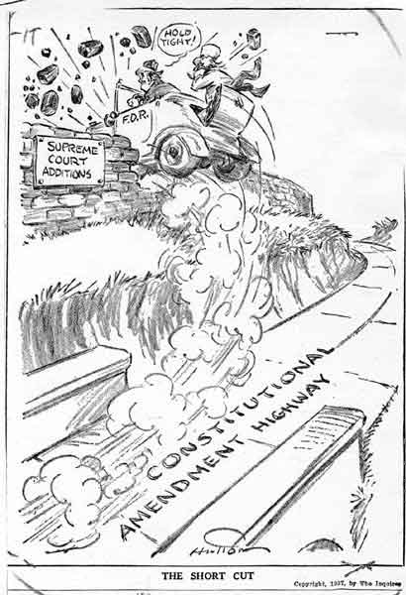
Cartoon Analysis: The New Deal and The High Court Challenge/ 1933-1937

February 7, 1937, Washington Post, "Samson"

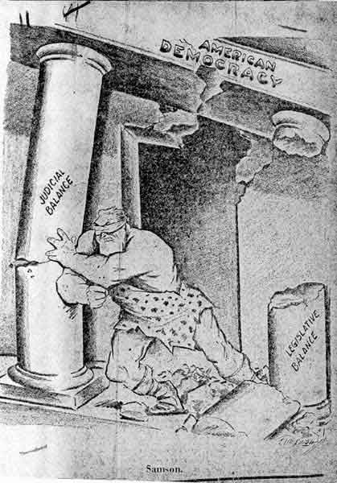

February 8, 1937, Philadelphia Inquirer-Public Ledger, "The Short Cut"

|
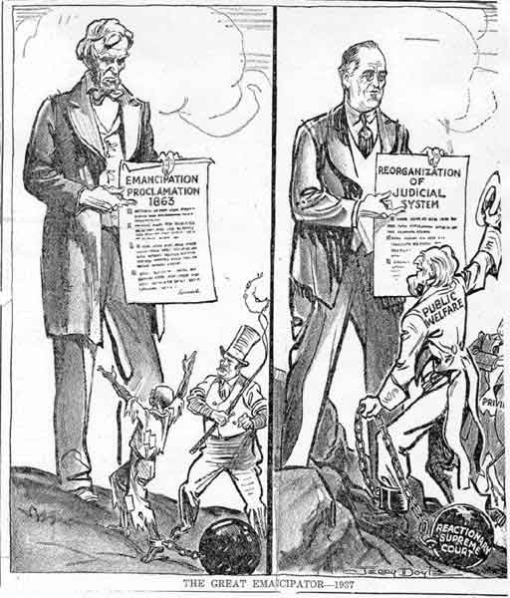
February 8, 1937, New York Post, "The Great Emancipator—1937"

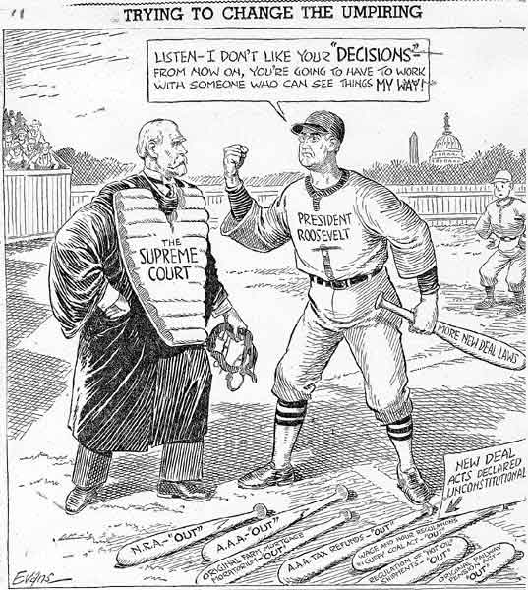

February 10, 1937, Columbus (Ohio) Dispatch, "Trying to Change the Umpiring"

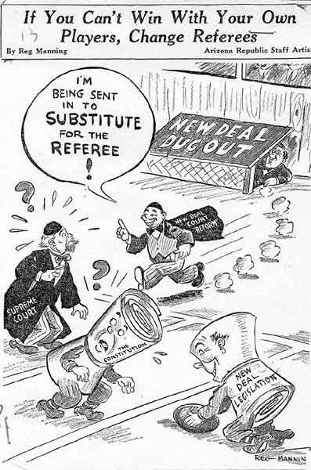
Cases | Speeches | Articles | Letters | Cartoons
February 11, 1937, Phoenix (Ariz.) Republic,
“If you cant win with your own players, change referees”

